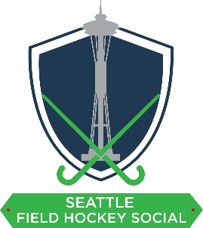
Event: Seattle Field Hockey Social

Date: Saturday, August 10 – Sunday, August 11, 2019; 9am – 5pm

Location: Marymoor Park, 6046 West Lake Sammamish Pkwy NE, Redmond, WA 98073

Description: This social field hockey tournament is the first of its kind to be hosted in the Seattle region. The tournament will include women’s, men’s, and mixed divisions with teams composed of players from across the United States and Canada. Friends, family, and community members will support the event over the tournament weekend. A beer garden (21+ only) and food trucks will be available near the fields for participants and spectators.

Goal: To raise funds to cover the field fees and other expenses for the tournament (i.e. signage, hydration stations, balls)

Organization: Seattle Field Hockey Social is a WA Nonprofit Corporation (UBI Number: 604200249)

Website: http://www.seattlefieldhockeysocial.com/

Sponsorship levels are available at Platinum ($1000+), Gold ($500), Silver ($200), and Bronze ($100). All in-kind donations will be recognized as sponsorships by donated value. See the following page for the benefits of sponsorship.

If your company is able to provide sponsorship, please complete all fields below and email your business logo to seattleFHsocial@gmail.com.

Company: Click or tap here to enter text.
Contact Name: Click or tap here to enter text.
Email: Click or tap here to enter text.
Phone: Click or tap here to enter text.
Sponsorship Level
☐ Platinum ($1000+)
☐ Gold ($500)
☐ Silver ($200)
☐ Bronze ($100)

Sponsorship Benefits | Platinum | Gold | Silver | Bronze
 | $1000 | $500 | $200 | $100
Sponsorship right to the tournament
The tournament will be known as the Seattle Field Hockey Social proudly sponsored by (Your Company)
Exclusive rights to the event
No direct competitor of the platinum sponsor can take up any other sponsorship offer (e.g. only one bank, sporting goods store, etc.)
Printed banner
Your Company will have a 4’ x 6’ banner printed for the event and displayed at the venue
Acknowledgement of sponsorship level over the microphone throughout the event and at Saturday social event
Display banner
Your Company may display a banner provided by your company (limit 4’ x 6’)
Acknowledgement on Seattle Field Hockey Social website, Facebook page, tournament program, and banner
Promotional access to team bags to be distributed at the tournament (e.g. special offer, business card, flyer, menu, etc.)

